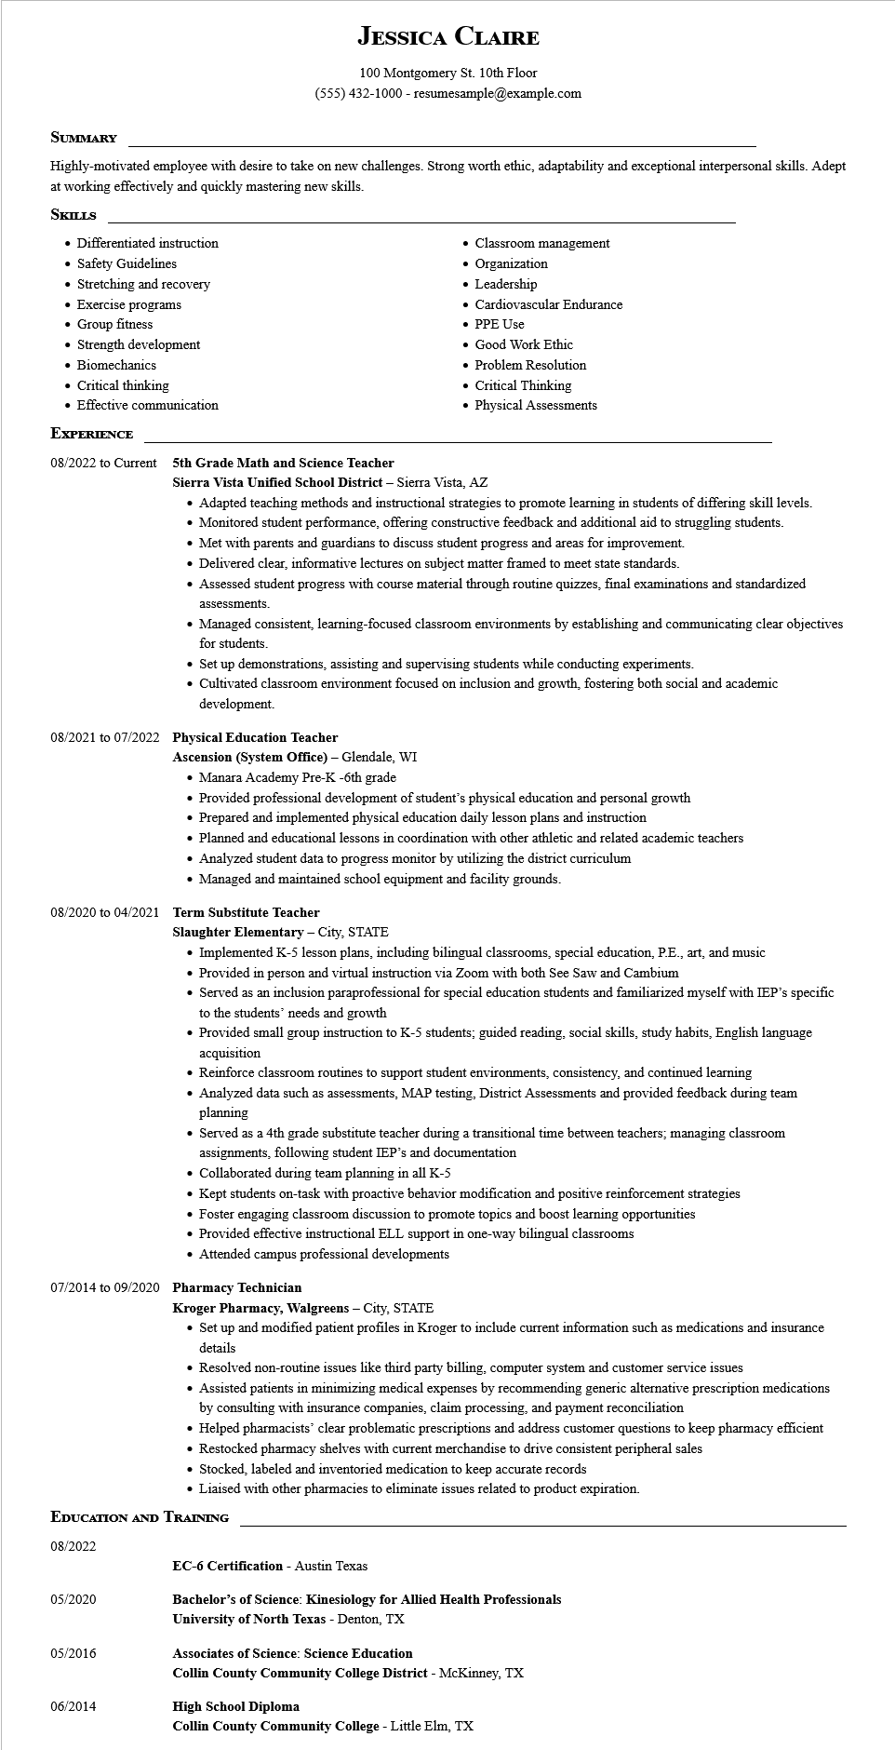
JESSICA CLAIRE
100 Montgomery St. 10th Floor
(555) 432-1000 - resumesample@example.com
SUMMARY
Highly-motivated employee with desire to take on new challenges. Strong worth ethic, adaptability and exceptional interpersonal skills. Adept at working effectively and quickly mastering new skills.
SKILLS
• Differentiated instruction
• Safety Guidelines
• Stretching and recovery
• Exercise programs
• Group fitness
• Strength development
• Biomechanics
• Critical thinking
• Effective communication
• Classroom management
• Organization
• Leadership
• Cardiovascular Endurance
• PPE Use
• Good Work Ethic
• Problem Resolution
• Critical Thinking
• Physical Assessments
EXPERIENCE
08/2022 to Current
5th Grade Math and Science Teacher
Sierra Vista Unified School District - Sierra Vista, AZ
• Adapted teaching methods and instructional strategies to promote learning in students of differing skill levels.
• Monitored student performance, offering constructive feedback and additional aid to struggling students.
• Met with parents and guardians to discuss student progress and areas for improvement.
• Delivered clear, informative lectures on subject matter framed to meet state standards.
• Assessed student progress with course material through routine quizzes, final examinations and standardized assessments.
• Managed consistent, learning-focused classroom environments by establishing and communicating clear objectives for students.
• Set up demonstrations, assisting and supervising students while conducting experiments.
• Cultivated classroom environment focused on inclusion and growth, fostering both social and academic
development.
08/2021 to 07/2022 Physical Education Teacher
Ascension (System Office) - Glendale, WI
• Manara Academy Pre-K -6th grade
• Provided professional development of student's physical education and personal growth
• Prepared and implemented physical education daily lesson plans and instruction
• Planned and educational lessons in coordination with other athletic and related academic teachers
• Analyzed student data to progress monitor by utilizing the district curriculum
• Managed and maintained school equipment and facility grounds.
08/2020 to 04/2021 Term Substitute Teacher
Slaughter Elementary - City, STATE
• Implemented K-5 lesson plans, including bilingual classrooms, special education, P.E., art, and music
• Provided in person and virtual instruction via Zoom with both See Saw and Cambium
• Served as an inclusion paraprofessional for special education students and familiarized myself with IEP's specific to the students' needs and growth
• Provided small group instruction to K-5 students; guided reading, social skills, study habits, English language acquisition
• Reinforce classroom routines to support student environments, consistency, and continued learning
• Analyzed data such as assessments, MAP testing, District Assessments and provided feedback during team planning
• Served as a 4th grade substitute teacher during a transitional time between teachers; managing classroom assignments, following student IEP's and documentation
• Collaborated during team planning in all K-5
• Kept students on-task with proactive behavior modification and positive reinforcement strategies
• Foster engaging classroom discussion to promote topics and boost learning opportunities
• Provided effective instructional ELL support in one-way bilingual classrooms
• Attended campus professional developments
07/2014 to 09/2020 Pharmacy Technician
Kroger Pharmacy, Walgreens - City, STATE
• Set up and modified patient profiles in Kroger to include current information such as medications and insurance details
• Resolved non-routine issues like third party billing, computer system and customer service issues
• Assisted patients in minimizing medical expenses by recommending generic alternative prescription medications by consulting with insurance companies, claim processing, and payment reconciliation
• Helped pharmacists' clear problematic prescriptions and address customer questions to keep pharmacy efficient
• Restocked pharmacy shelves with current merchandise to drive consistent peripheral sales
• Stocked, labeled and inventoried medication to keep accurate records
• Liaised with other pharmacies to eliminate issues related to product expiration.
EDUCATION AND TRAINING
08/2022
EC-6 Certification - Austin Texas
05/2020
Bachelor's of Science: Kinesiology for Allied Health Professionals
University of North Texas - Denton, TX
05/2016
Associates of Science: Science Education
Collin County Community College District - McKinney, TX
06/2014
High School Diploma
Collin County Community College - Little Elm, TX

